Group Three
XBRL Project Database Software Engineering Specifications -
Appendix-G
Data Communiqué
Gino Gervasio | Theodora Kampelou | Nathalie Neptune | Anand Patil | James Wu
May 5th, 2010

Table of Contents
1. Software Specifications 3

Software Specifications

Use Case Specification
For the XBRL Project, only one use case has been identified. This use case encompasses the requirements specified by Data Communiqué. Below is the outlined use case.
Use Case Name: View XBRL instance document.
Goal:
To view the interactions of the different components of XBRL in a human readable format.
Summary:
The XBRL framework has many different components where information is pulled from the different parts. The user clicks a link and the sample instance document and all the information that it references is displayed in formatted HTML. The user has the option of selecting a specific project out of a list from the instance document and exporting the selected project into a Microsoft Excel spreadsheet.
Actors:
Primary: User
Preconditions:
None
Trigger:
User action
Basic Flow:
User goes to the URL
XBRL instance document is displayed in HTML

User can select a different project
User can export the selected project to a Microsoft Excel spreadsheet
Post Conditions:
User sees the selected project displayed in HTML. In addition, a button appears which allows the user to export the project details into an Excel document.
Notes:
XBRL - eXtensible Business Reporting Language
Instance Document - XBRL file containing project information.
XLS - Microsoft Excel Spreadsheet
XSD - XML Schema Definition file
Resources:
Data
Instance Document
Label Linkbase
Presentation Linkbase
XML Schema Definition File

View XBRL instance document Use Case Diagram
On page load, the data is rendered on the web page. The actor then has two options, the actor could either: view the XBRL (or a different project of the XBRL) or he could export to Microsoft Excel.
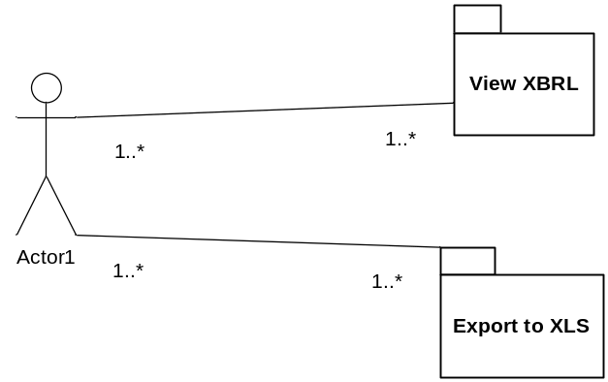

Activity Diagram
The start of the activity begins when the user goes to the URL. The page then displays all the information once it completes loading. Once the page has loaded, the user can either select a different project in the XBRL or export to Microsoft Excel.
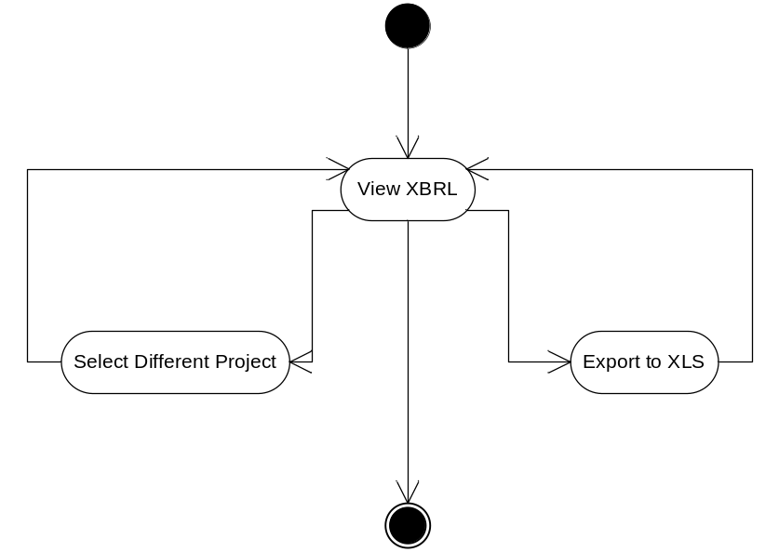

Sequence Diagram
At the code level, the controller, in our case a Servlet, invokes the XMapper, which is responsible for mapping the data in the XBRL framework, which subsequently requires loading the XBRL files. Hence, the XLoader class is invoked so that all the files are read and loaded in an implementation of a DiscoverableTaxonomySet, which is traversed and mapped by the XMapper, which consequently renders the information on an XSLT file.
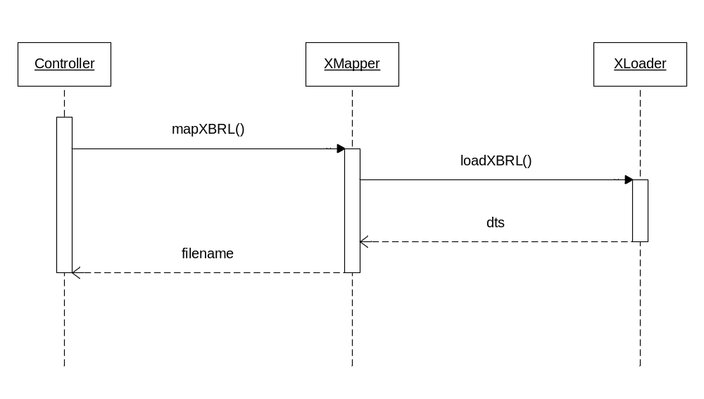
The conversion entails a shorter process, wherein the Controller, which is still the Servlet, invokes the Converter class via the convertToXLS method, which performs the conversion of the XSLT file to a Microsoft Excel spreadsheet.
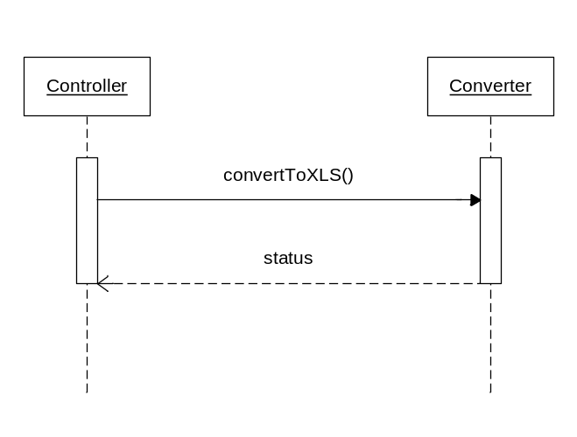
Deployment Diagram
The web application will be deployed in a Tomcat version 6.0.28 web server, which could run on any x86 server. The user can access the application through any browser on any workstation.
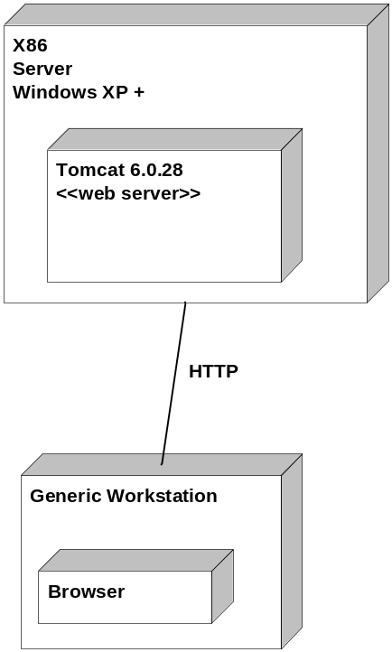

Use Case Evaluation
The following metrics have been identified to evaluate the use case outlined above.
Name | Baseline | Used to Measure
Data Accuracy | 99.9% | The data that is displayed is 99.9% accurate to the input file
Page Load | 1.0 sec | The page is loaded within the baseline SLA. Loading page includes rendering of XBRL document.

